The Beach House Times
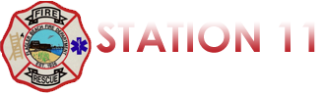
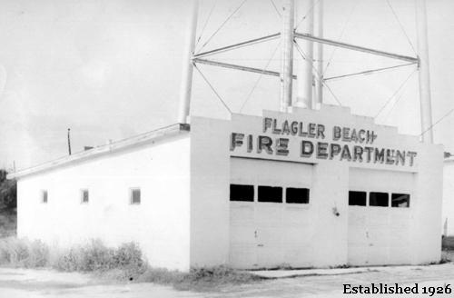

Quarterly Newsletter April 1st, 2018 – June 31^{st,} 2018

The Numbers Page
This quarter, Flagler Beach Fire Department was dispatched to the following calls for service:

Medical Emergencies: 175 Service Calls*: 66

Vehicle Accidents: 48 Fire Alarms: 23

Hazardous Conditions**: Structure Fires: 25
HazMat: 4 Brush Fires: 6

Aircraft Emergency: 0 Vehicle Fires: 1

Water Rescues: 8 Elevator Incident: 2

LEO Assist: 11 Animal Rescue: 0

*Service Calls include, but are not limited to, installing smoke detectors, invalid assists, unlocking children/pets from vehicles, unauthorized camp/bon fires, assisting law enforcement, etc.
**Hazardous Conditions include, but are not limited to, arcing/downed power lines, large/excessive road debris, damaged/leaking hydrants, collapsed dune walkovers, etc.
Summer Safety Tips
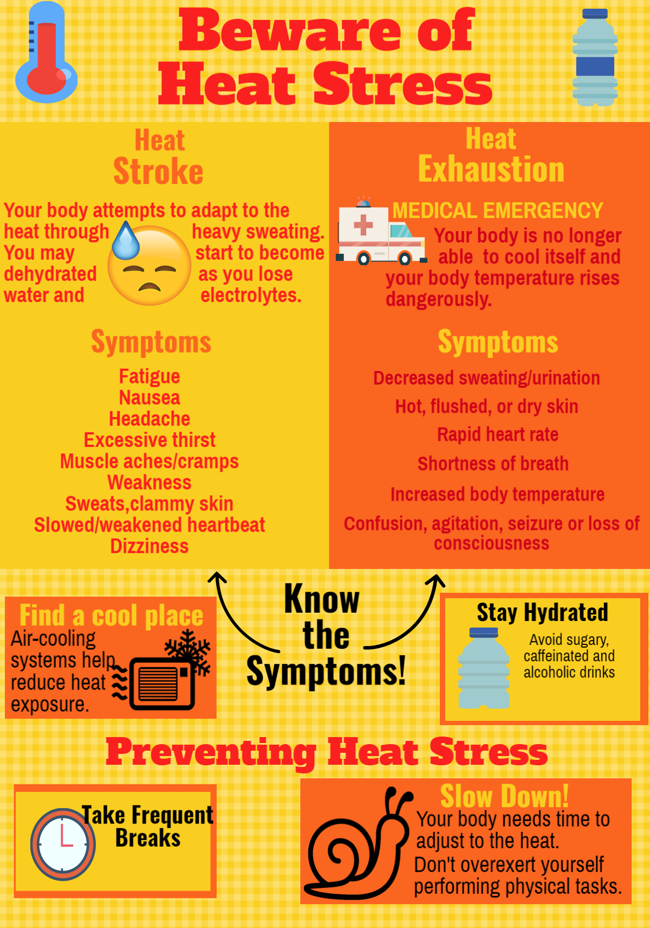
Severe Storm Precautions 