The Beach House Times
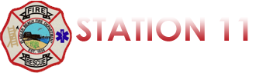
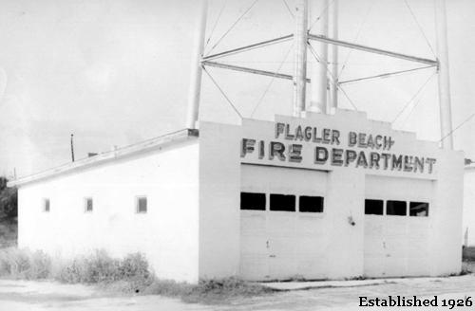

Quarterly Newsletter
July 1st, 2017– September 30th, 2017

The Numbers Page
This quarter, Flagler Beach Fire Department was dispatched to the following calls for service:

Medical Emergencies: 168 Service Calls*: 113

Vehicle Accidents: 23 Fire Alarms: 26

Hazardous Conditions**: 50 Structure Fires: 23
HazMat: 6 Brush Fires: 10

Aircraft Emergency: 1 Vehicle Fires: 5

Water Rescues: 7 Boat Fire: 1

Dumpster Fire: 1 Animal Rescue: 0

*Service Calls include, but are not limited to, installing smoke detectors, invalid assists, unlocking children/pets from vehicles, unauthorized camp/bon fires, assisting law enforcement, etc.
**Hazardous Conditions include, but are not limited to, arcing/downed power lines, large/excessive road debris, damaged/leaking hydrants, collapsed dune walkovers, etc.
Winter Safety Tips
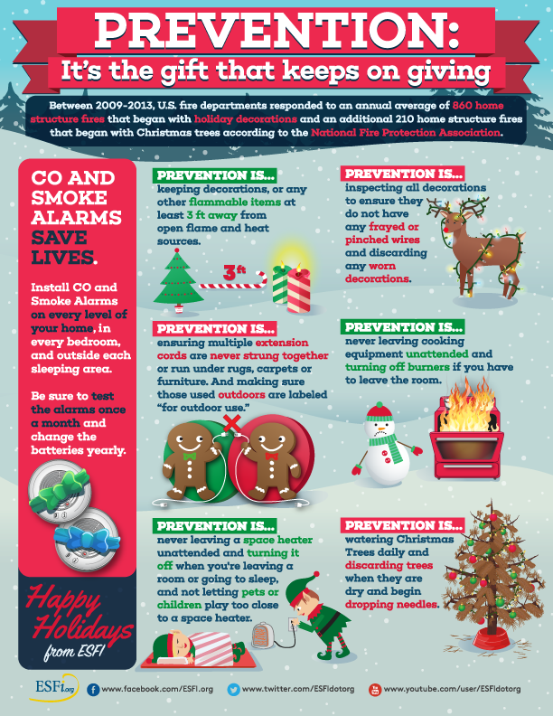
Winter Safety Tips
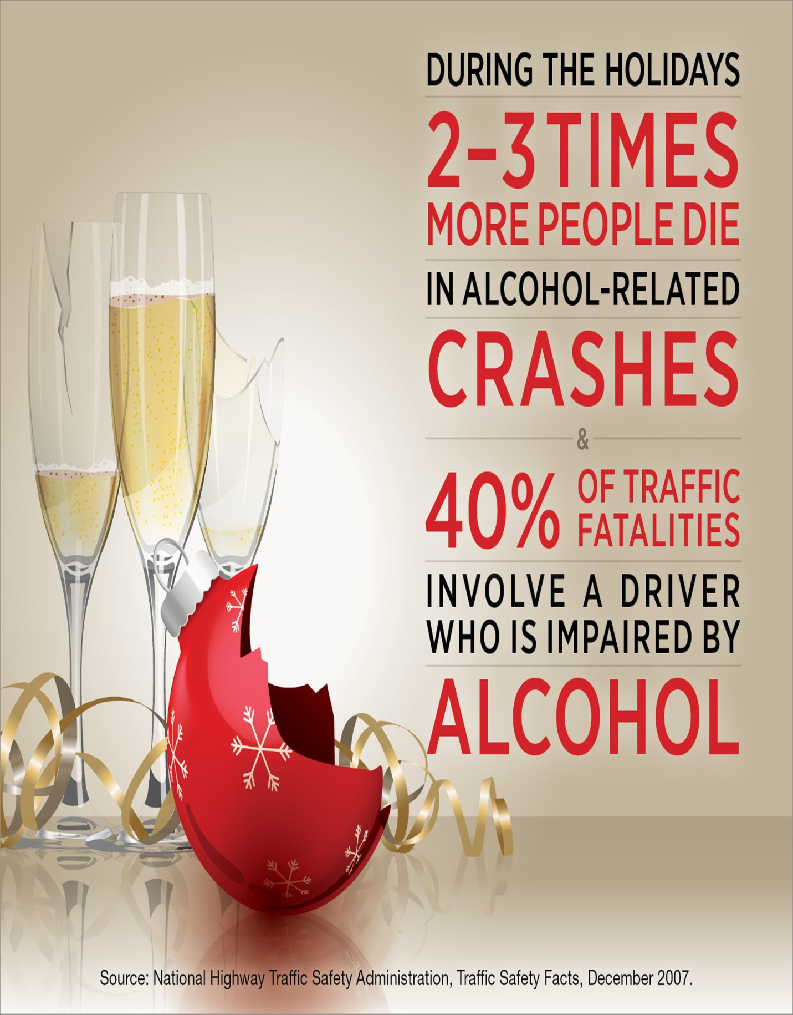
Hurricane Irma
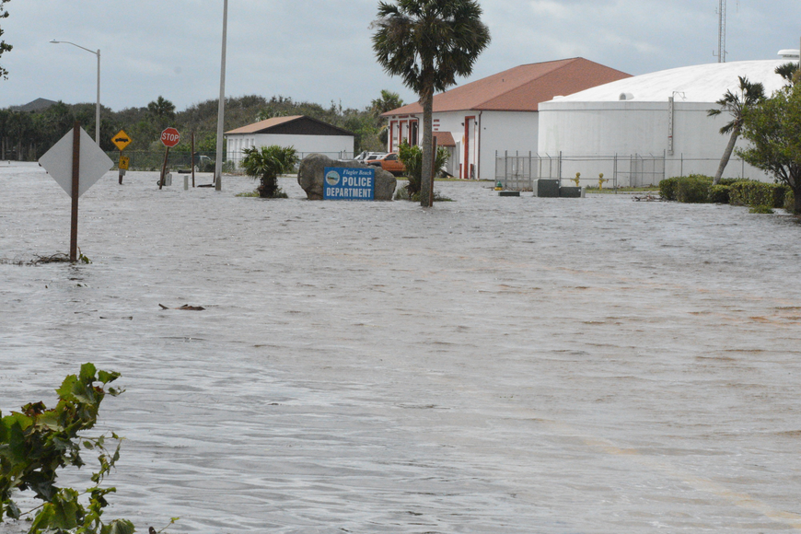
Hurricane Irma brought a lot of devastation to our beautiful beach town. To this day there are hundreds of people in our city still dealing with the aftermath of this disaster. The support of our community has been overwhelming and truly an incredible show of honor, courage and commitment. We here at the Flagler Beach Fire Department would like to thank each and every one of you for everything you have done. This is our community and we will continue to move forward. Thank you Flagler Beach!

